Technique documents

Forensic Techniques - murder mystery

CUPGE1 – semester 2

SCELVA

FINGERPRINTING

Each time we touch something, it is likely that we leave behind our unique signature—in our fingerprints.

No two people have the same fingerprints. Even identical twins, with identical DNA, have different fingerprints.

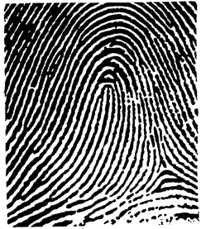The fingerprint pattern, such as the print left when an inked finger is pressed onto paper, is that of the friction ridges on that finger. Friction ridge patterns are grouped into three distinct types—loops, whorls, and arches—each with unique variations, depending on the shape and relationship of the ridges:

**Loops** - prints that recurve back on themselves to form a loop shape. Divided into radial loops (pointing toward the radius bone, or thumb) and ulnar loops (pointing toward the ulna bone, or pinky), loops account for approximately 60 percent of pattern types.

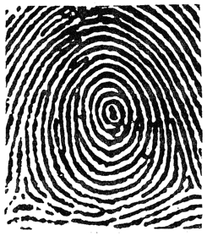**Whorls** - form circular or spiral patterns, like tiny whirlpools. There are four groups of whorls: plain (concentric circles), central pocket loop (a loop with a whorl at the end), double loop (two loops that create an S-like pattern) and accidental loop (irregular shaped). Whorls make up about 35 percent of pattern types.

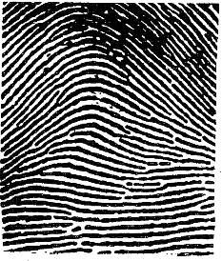

**Arches** - create a wave-like pattern and include plain arches and tented arches. Tented arches rise to a sharper point than plain arches. Arches make up about five percent of all pattern types.

Fingerprints can be found on practically any solid surface, including the human body. Analysts classify fingerprints into three categories according to the type of surface on which they are found and whether they are visible or not: Fingerprints on soft surfaces (such as soap, wax, wet paint, fresh caulk, etc.) are likely to be three-dimensional plastic prints; those on hard surfaces are either patent (visible) or latent (invisible) prints. Visible prints are formed when blood, dirt, ink, paint, etc., is transferred from a finger or thumb to a surface. Patent prints can be found on a wide variety of surfaces: smooth or rough, porous (such as paper, cloth, or wood) or nonporous (such as metal, glass, or plastic).

Latent prints are formed when the body’s natural oils and sweat on the skin are deposited onto another surface. Latent prints can be found on a variety of surfaces; however, they are not readily visible, and detection often requires the use of fingerprint powders, chemical reagents, or alternate light sources. The smoother and less porous a surface is, the greater the potential that any latent prints present can be found and developed.

More information on fingerprint analysis:

 <https://www.bbc.com/news/magazine-19740979>

 <https://www.forensicsciencesimplified.org/prints/index.htm>

<https://science.howstuffworks.com/fingerprinting.htm>

<https://www.bbc.com/news/av/uk-england-london-49933939>

AUTOPSY

In death investigations, autopsies are most often performed by a **forensic pathologist.** A pathologist studies the effects of diseases, medical treatments, and injury on the human body. A forensic pathologist specialises in using these studies to establish a legally admissible manner of death in a court of law.

There are four legally defined manners of death:

* Natural
* Accident
* Homicide
* Suicide

After careful examination of all the evidence at hand, the forensic pathologist will assign a cause of death as one of these four manners.

For example, if the autopsy reveals a natural disease process such as cancer, then the death would be considered **natural.**

The answers are not always that clear. The pathologist must consider all the information. Severe head injuries that result in death with no evidence of assault could be hard to explain. But when that evidence is added to the police report that states the body was found next to an ice-covered, fallen ladder, the manner of death is an **accident**

It would be easy to assume a gunshot wound is the result of a **homicide.** But an autopsy could reveal that the wound patterns, angle of bullet entry and gun powder residue indicate that the gun was fired while being held by the victim. The wounds are self-inflicted, so that would be ruled a **suicide.**

One of the greatest challenges of an autopsy is examining the wounds. The essence of the medical examiner's job is to use their skill and experience to determine the true nature and cause of a particular wound. Depending on the type of wound or weapon used, this can get difficult.

For more information:

<https://science.howstuffworks.com/autopsy.htm>

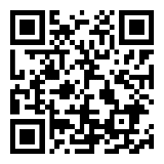<https://www.britannica.com/topic/autopsy>

TIME OF DEATH

Estimating the time of death for the deceased is something that the pathologist will have to do during his autopsy procedures. In addition to this they may be called upon at the scene of a crime whilst carrying out their external examinations to try and judge – or best guess – when the victim died.

**At the Scene**

It may sound silly but one of the first things to do once a crime scene has been secured and all relevant details documented; is to check for a watch. If the victim does have a watch is it broken? If it is then the watch will more than likely have stopped at the time of the individual’s death, especially if they have had a heavy impact or long fall.

**Categorising Time of Death**

Time of death is categorised in three ways:

* Physiological time of death: The point at which the deceased’s body – including vital organs – ceased to function.
* Estimated time of death: A best guess based on available information.
* Legal time of death: The time at which the body was discovered or physically pronounced dead by another individual. This is the time that is shown – by law – on a death certificate.

**Methods Used**

One method of estimating the time of death is to measure **body temperature**. The normal equation for this is:

37.5oC – 1.5oC

This formula equates to the body temperature (37.5oC), which loses 1.5oC per hour until the temperature of the body is that of the environment around it; known as the ambient temperature. This ambient temperature – depending on how low it is – may take minutes or hours to be reached and this is a good indicator as to how long a body has been in situ.

The most common way of taking the temperature of the deceased is to use a rectal thermometer or to take a temperature reading from the liver, which can achieve a more realistic core body temperature.

**Rigor Mortis** also acts as a good measuring stick for estimating the time of death. This natural process which occurs in all of us when we die and is the natural contracting and relaxation of the body’s muscles caused by changes in the body’s chemical balances.

Rigor normally occurs in the smaller muscles such as those in the face and neck and will work its way down through the body as the muscles become larger. **The process normally begins roughly two hours after death and can last for anything from twenty to thirty hours**. It is a common misconception that rigor does not leave the body; it will after these time frames have elapsed.

Forensic Entomology (the study of insects) is another way in which the time of death can be estimated. By studying the insects found at the crime scene the pathologist can establish a more accurate time scale depending on which insects are found on the body and what stages they are at in their life cycle.

For more information:

<https://www.exploreforensics.co.uk/measuring-body-temperature.html>

[https://www.exploreforensics.co.uk/rigor-mortis-and-lividity.html#more-157](https://www.exploreforensics.co.uk/rigor-mortis-and-lividity.html" \l "more-157)

<https://www.exploreforensics.co.uk/estimating-the-time-of-death.html>

<https://www.exploreforensics.co.uk/forensic-entomology.html>



BLOODSTAINS

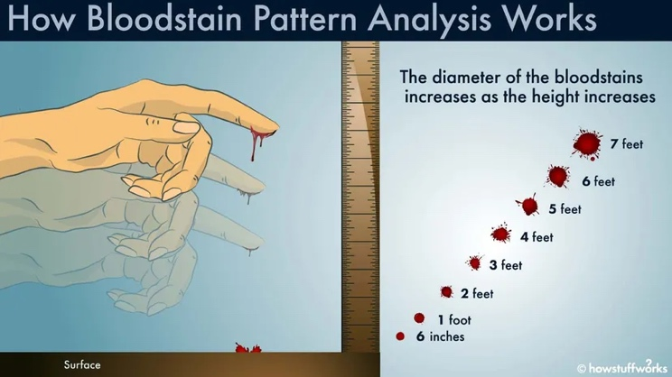

The diameter of a blood drop will increase as the height from which it falls increases.

When a crime results in bloodshed, it functions as evidence for investigators. However, blood spatter analysis takes time and provides only a few pieces of the total crime puzzle.

After close analysis, blood spatters can provide important clues such as:

* type of weapon
* velocity of blood
* number of blows
* position and movements of victim and assailant during and after the attack
* which wounds were inflicted first
* type of injuries
* when the crime took place
* whether death was immediate or delayed

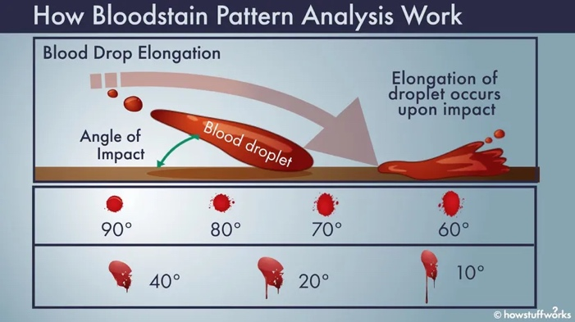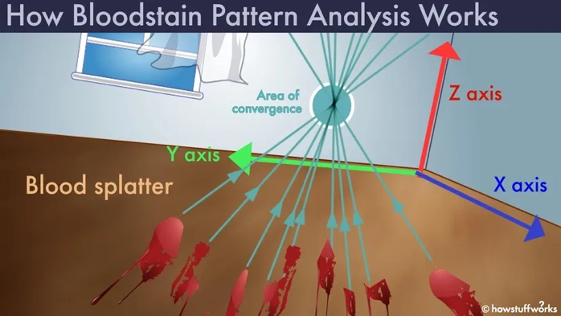

Blood behaves similarly to spilled water droplets, and the speed at which the droplets travel when they strike a surface- the **target**— affects their shape. This speed, combined with angle and surface characteristics, also determines how far blood droplets travel after meeting a barrier.

One pattern of slow-moving blood, called "**drips**," occurs after an injury, and has a relatively large footprint of 4 mm or more. They result from blood dripping onto blood, can fall from a bleeding wound, or a motionless, bloodied weapon or object.

A moving object produces what's known as a **cast-off pattern**. Other low-velocity patterns include blood **pooling around** a victim's body and impressions left by bloody objects. This latter phenomenon, called a **transfer**, sometimes retains the shape of the object that made it

At the other end of the scale are the **tiny droplets caused by blood travelling at high speeds**. These are usually caused by gunshot wounds, but they can also result from explosions, power tools or high-speed machinery. These fast-moving drops leave stains measuring less than 1 mm across.

Between these extremes lies a range of **medium-sized droplets**. Typically measuring 1 to 4 millimetres, they can be caused by a blunt object such as a bat or a fist, or can result from stabbing, cast-offs or even bloody coughs.

Several factors complicate their analysis. For example, during a beating or stabbing, arterial damage can cause the subject to bleed faster.

In addition to spatters, analysts look for **voids,** aka blockages. In the case of a high-density spatter, these gaps in the pattern indicate that something in the way, potentially the assailant, caught some of the victim's blowback.

Drop size is only one aspect used in analysing blood spatters.

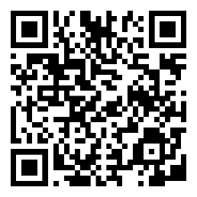**For more information:**

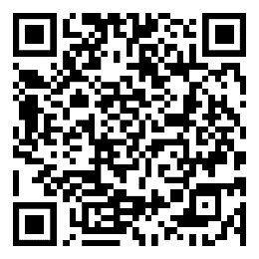 <https://www.forensicsciencesimplified.org/blood/index.htm>

<https://science.howstuffworks.com/bloodstain-pattern-analysis.htm>

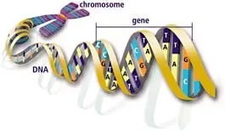DNA PROFILING

Police officers and detectives often work closely with laboratory personnel or evidence collection technicians to make sure evidence isn't contaminated. This involves wearing gloves and using disposable instruments, which can be discarded after collecting each sample. While collecting evidence, officers are careful to avoid touching areas where DNA evidence could exist. They also avoid talking, sneezing, and coughing over evidence or touching their face, nose or mouth.

The following list shows some common sources of DNA evidence:

* A weapon, such as a baseball bat, fireplace poker or knife, which could contain sweat, skin, blood or other tissue
* A hat or mask, which could contain sweat, hair or dandruff
* A facial tissue or cotton swab, which could contain mucus, sweat, blood or earwax
* A toothpick, cigarette butt, bottle or postage stamp, all of which could contain saliva
* A used condom, which could contain semen or vaginal or rectal cells
* Bed linens, which could contain sweat, hair, blood or semen
* A fingernail or partial fingernail, which could contain scraped-off skin cells

When a suspect is present, investigators take a DNA sample from the suspect, send it to a lab and receive a DNA profile. Then they compare that profile to a profile of DNA taken from the crime scene. There are three possible results:

* **Inclusions** -- If the suspect's DNA profile matches the profile of DNA taken from the crime scene, then the results are considered an inclusion or nonexclusion. In other words, the suspect is included (cannot be excluded) as a possible source of the DNA found in the sample.
* **Exclusions** -- If the suspect's DNA profile doesn't match the profile of DNA taken from the crime scene, then the results are considered an exclusion or noninclusion. Exclusions almost always eliminate the suspect as a source of the DNA found in the sample.
* **Inconclusive results** -- Results may be inconclusive for several reasons. For example, contaminated samples often yield inconclusive results. So do very small or degraded samples, which may not have enough DNA to produce a full profile.

For more information:

<https://www.forensicsciencesimplified.org/dna/why.html>

<https://science.howstuffworks.com/dna-profiling.htm>

<https://science.howstuffworks.com/life/genetic/dna-evidence1.htm>

<https://science.howstuffworks.com/why-dna-evidence-can-be-unreliable.htm>

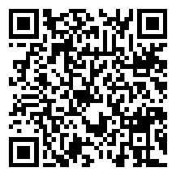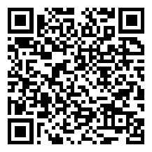

SUSPECT INTERVIEWS

Starting an investigation, the facts, victims, witnesses, and suspects are established.

To help eliminate possible suspects is to determine their **alibi**. True alibis are usually easy to verify with a witness, a video, or other concrete information. The harder alibi to prove or disprove is where the subject was alone or at a function where no one would remember them — e.g. jogging in the park. In these cases, one would talk to the people there — look for video or other information to prove the alibi.

Unfortunately, **a failure to prove the alibi is not proof the subject committed the crime. The goal is to break the alibi.**

**Breaking the Alibi**

The basic principle of breaking the alibi is simple — it is getting the subject to change their story. When a truthful person tells you their story, it is the only story they have to tell. When you challenge them, they will not change the story. They may give you additional information, but it will not conflict with their alibi story.

If you continue to push a truthful person, insinuating they are not telling the truth, they will become angry. Their story is the only one they have to tell.

A person who has constructed a false alibi has to create a story about where they were or why it was not them that committed the crime. The problem with this is, it is very hard to construct a story that takes into consideration every possible element. When the subject is presented with an unknown element that challenges their story, they have to make up more lies to accommodate the new information.

**How Does a Lie Detector (Polygraph) Work?**

Y­ou hear about lie detectors police investigations, and sometimes a person applying for a job will have to undergo a polygraph. The goal of a lie detector is to see if the person is telling the truth or lying when answering certain questions.

When a person takes a polygraph test, four to six sensors are attached to him. A polygraph is a machine in which the multiple ("poly") signals from the sensors are recorded on a single strip of moving paper ("graph"). The sensors usually record:

* The person's **breathing rate**
* The person's **pulse**
* The person's **blood pressure**
* The person's **perspiration**

Sometimes a polygraph will also record things like arm and leg movement.

When the polygraph test starts, the questioner asks three or four simple questions to establish the norms for the person's signals. Then the real questions being tested by the polygraph are asked. Throughout questioning, all the person's signals are recorded on the moving paper.

Both during and after the test, a polygraph examiner can look at the graphs and can see whether the vital signs changed significantly on any of the questions. In general, a significant change (such as a faster heart rate, higher blood pressure, increased perspiration) indicates that the person is lying.

When a well-trained examiner uses a polygraph, they can detect lying with high accuracy. However, because the examiner's interpretation is subjective and because different people react differently to lying, a polygraph test is not perfect and can be fooled.

For more information:

<https://www.exploreforensics.co.uk/forensic-psychology.html#more-116>

<https://science.howstuffworks.com/question123.htm>

<https://www.police1.com/investigations/articles/interview-and-interrogation-breaking-the-alibi-PrttCmxEQCm5Y3kb/>

